**LAB PROJECT**

WEB TECHNOLOGY LAB (CS – 229L)

***5th Semester Spring 2025***



**Online Movie Booking (WEB)**

Lab Teacher**: Sir Rahil**

**Project Members**

Abdul Haseeb Qazi **(2023F-BCS-078)**

Abdul Rehman **(2023F-BCS-100)**

Alishba Hamid **(2023F-BCS-339)**

**BS in Computer Science**

**Department of Computer Science & Information Technology**

Sir Syed University of Engineering and Technology

University Road Karachi – 75300

Hotflix

# 

Online Movie Booking System

**WEB TECHNOLOGY**

CHAPTER # 1..............................................................................................................................................

CERTIFICATE ..............................................................................................................................................

ACKNOWLEDGEMENT ............................................................................................................................

CHAPTER # 2..............................................................................................................................................

FUNCTION REQUIREMENT..............................................................................................................................

CHAPTER # 3……………………….....................................................................................................................

SYSTEM DESIGN.............................................................................................................................................

ERD DIAGRAM .............................................................................................................................................

CHAPTER # 4.............................................................................................................................................

ANALYSIS…………………………………………….......................................................................................................

CHAPTER # 5.............................................................................................................................................

CONCLUSION ……………………………………………................................................................................................

Chap -1

INTRODUCTION

## CERTIFICATE

This is to certify that the dissertation

entitled “***HOTFLIX*** - **Online Movie Booking System (database)**” is submitted by **Abdul Haseeb Qazi** *2023F-BCS-078*, **Abdul Rehman** *2023F-BCS-100*, **Alishba Hamid** *2023F-BCS-339* in their partial fulfilment of the requirement of the award of the Web Technology PROJECT.

Chap -2

FUNCTION REQUIREMENT

# FUNCTIONAL REQUIREMENT

* Every online booking needs to be associated with an account
* One account cannot be associated with multiple users
* Search results should enable users to find the most recent and relevant booking options
* System should enable users to book / pay for their tickets only in a timeboxed manner after tickets being added to the cart
* System should only allow users to move to payment only when mandatory fields such as date, time, location has been mentioned
* System should consider time zone synchronization when accepting bookings from different time zones
* User should be able to change password.

SOFTWARE:

 

PROGRAMMING LANGUAGE:

 

Chap -3

SYSTEM DESIGN:

INTRODUCTION TO UML:

DESIGN

UML Design the Unified Modelling Language (UML) is a standard language for specifying, visualizing, constructing, and documenting the software system and its components. It is a graphical language, which provides a vocabulary and set of semantics and rules. The UML focuses on the conceptual and physical representation of the

SYSTEM DESIGN:

❖ Visualizing ❖ Specifying ❖ Constructing ❖ Documenting Visualizing:

Through UML we see or visualize an existing system and ultimately, we visualize how the system is going to be after implementation. Unless we think, we cannot implement. UML helps to visualize, how the components of the system communicate and interact with each other.

Specifying:

Specifying means building, models that are precise, unambiguous and complete UML addresses the specification of all the important analysis design, implementation decisions that must be made in developing and deploying a software system.

Constructing:

UML models can be directly connected to a variety of programming language through mapping a model from UML to a programming language like JAVA or C++ or VB. Forward Engineering and Reverse Engineering is possible through UML.

Documenting:

The Deliverables of a project apart from coding are some Artifacts, which are critical in controlling, measuring and communicating about a system during its developing requirements, architecture, desire, source code, project plans, tests, prototypes releasers, etc.

ERD Diagram:

An entity–relationship model describes interrelated things of interest in a specific domain of knowledge. A basic ER model is composed of entity types and specifies relationships that can exist between entities

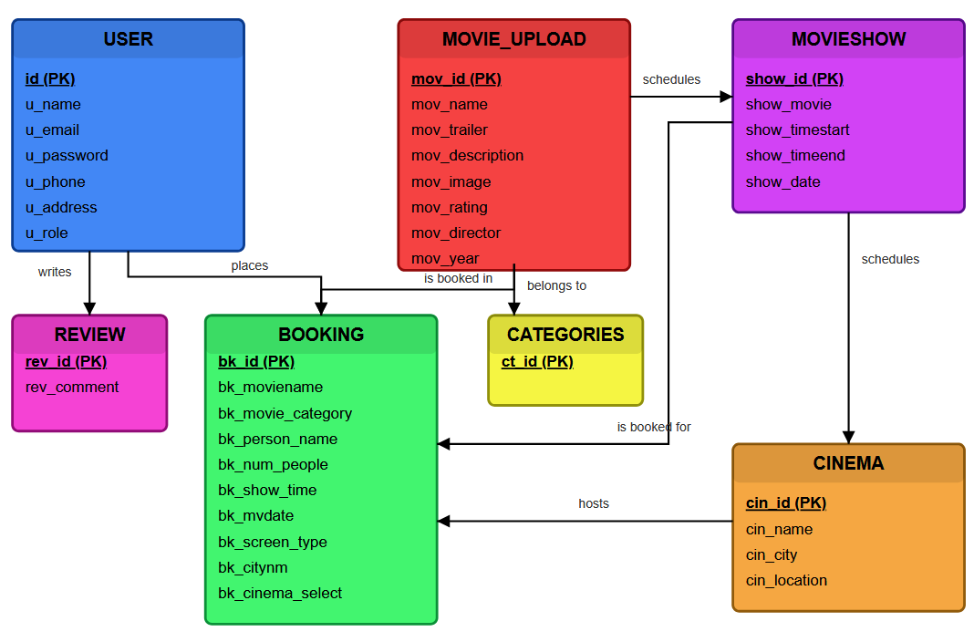

Chap -4

SYSTEM DESIGN:

INTRODUCTION TO UML:

UML Design the Unified Modelling Language (UML) is a standard language for specifying, visualizing, constructing, and documenting the software system and its components. It is a graphical language, which provides a vocabulary and set of semantics and rules. The UML focuses on the conceptual and physical representation of the system. It captures the decisions and understandings about systems that must be constructed. It is used to understand, design, configure, maintain, and control information about the systems. The UML is a language for:

SCREENSHOTS

❖ Visualizing ❖ Specifying ❖ Constructing ❖ Documenting Visualizing:

Through UML we see or visualize an existing system and ultimately, we visualize how the system is going to be after implementation. Unless we think, we cannot implement. UML helps to visualize, how the components of the system communicate and interact with each other.

Specifying:

SQL QUERY

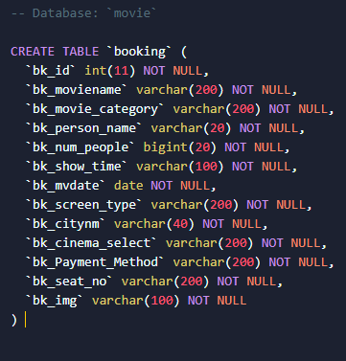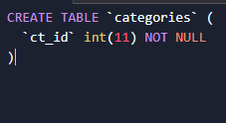

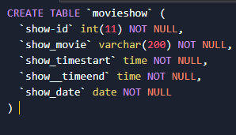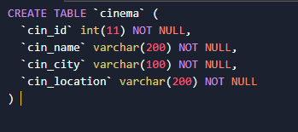

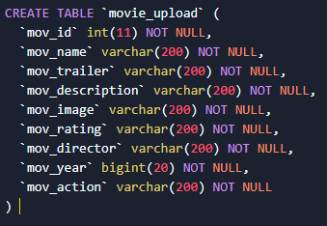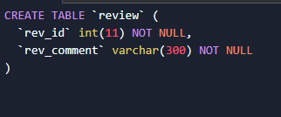

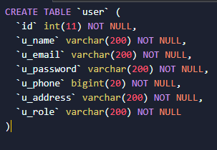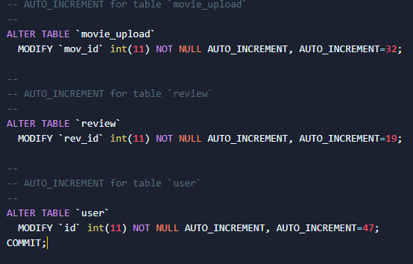

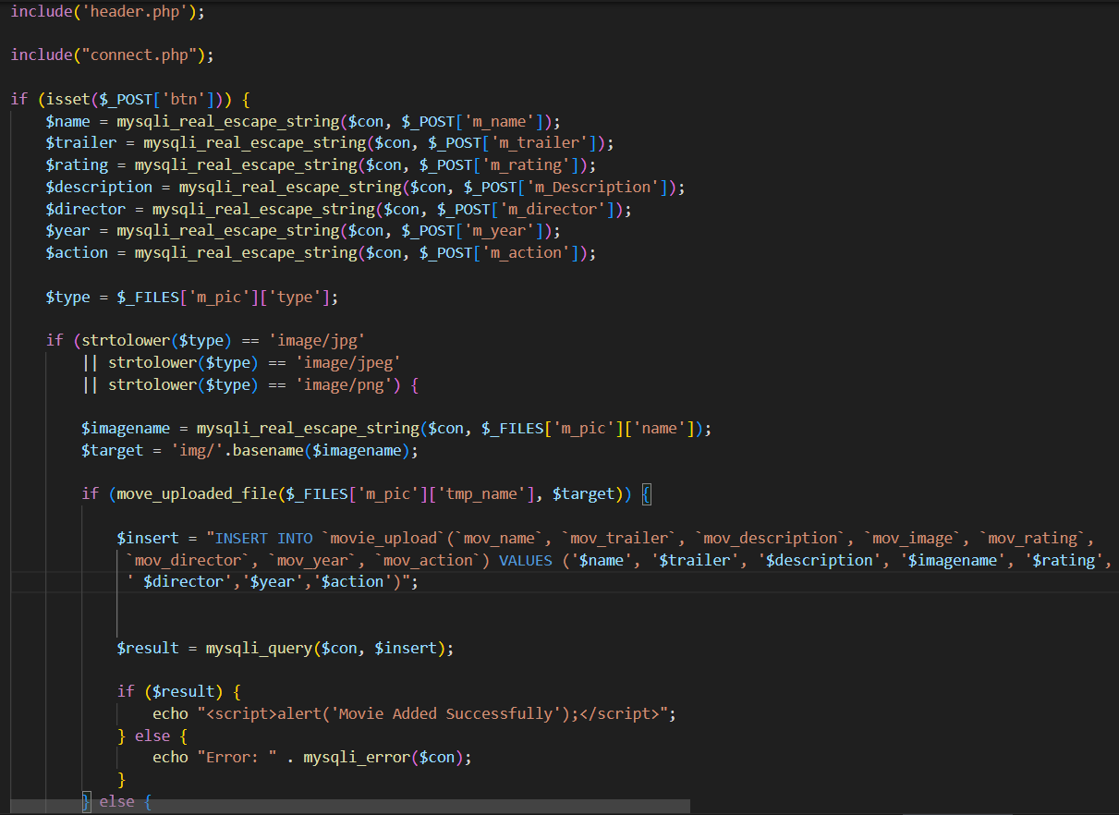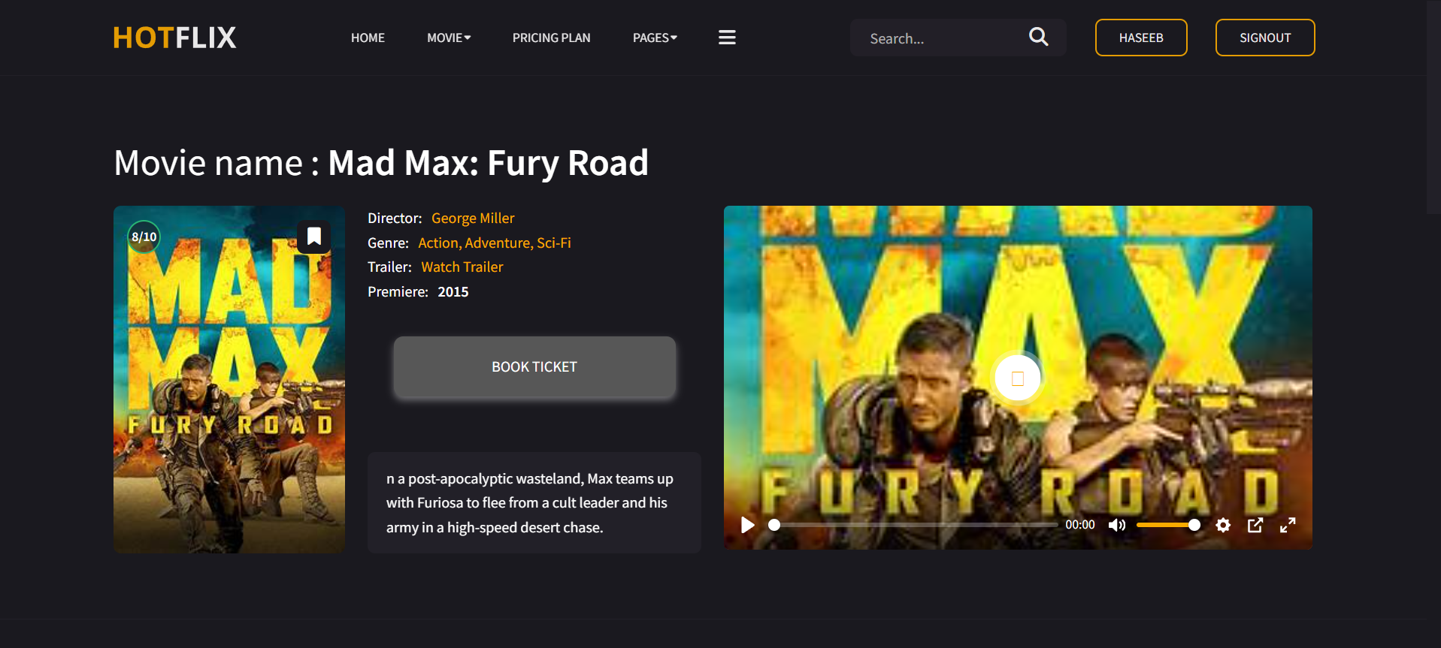

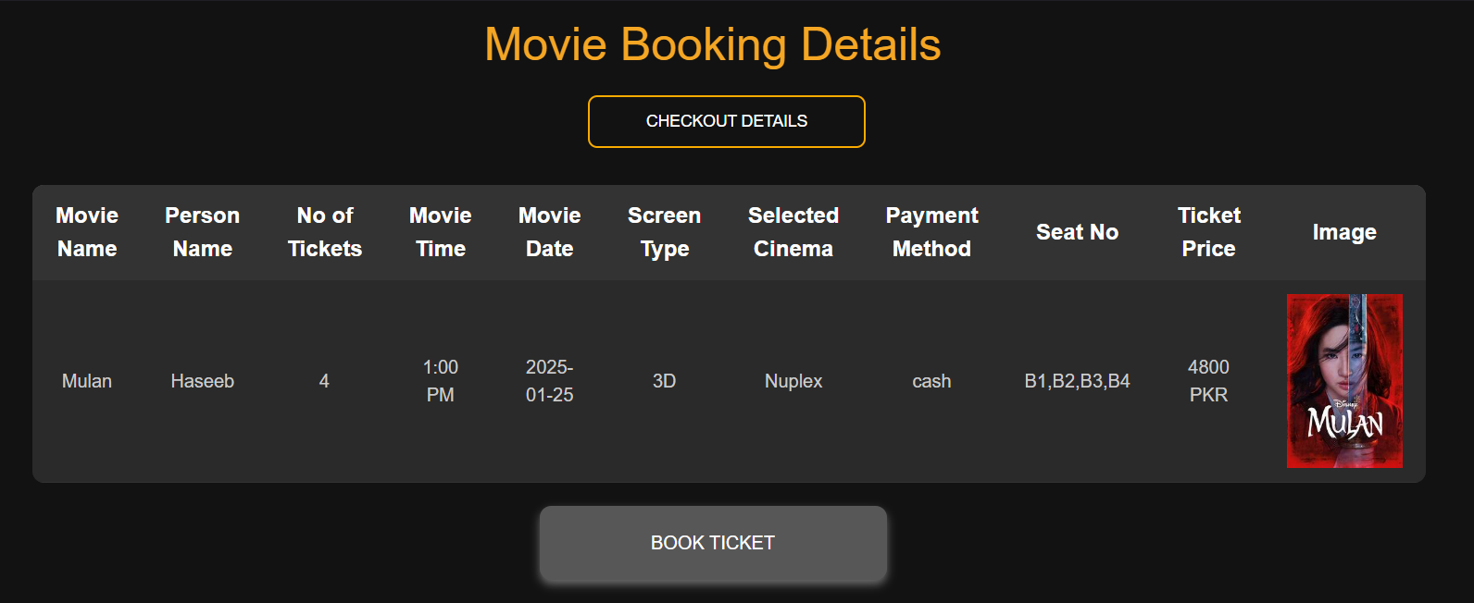

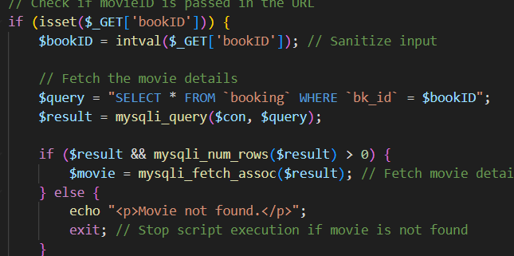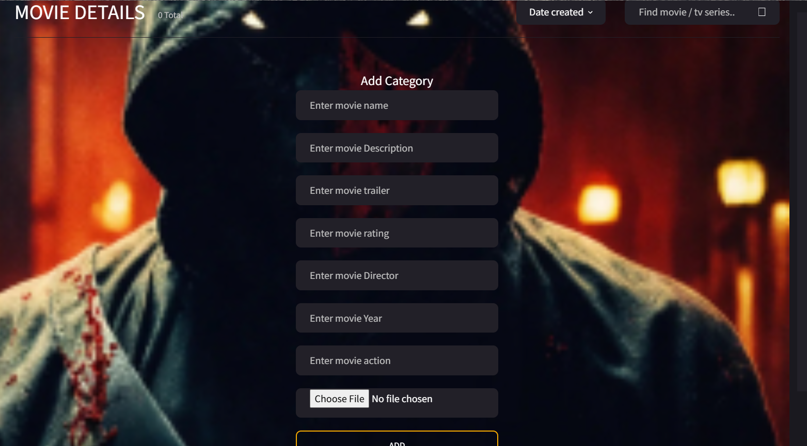

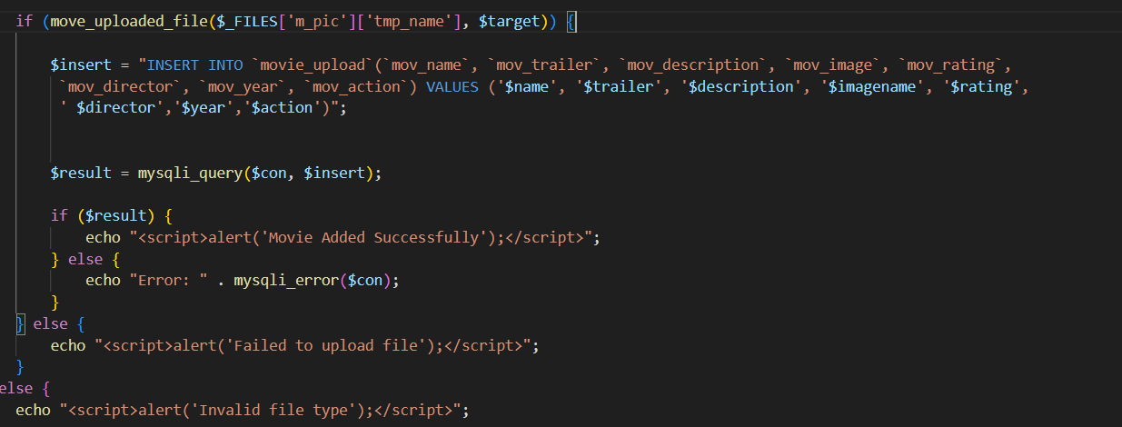

Chap -5

CONCLUSION

CONCLUSION

Finally, in Online movies ticket booking, we have developed a secure, user-friendly online movie ticket. Database System. This System can take care of each member whether its Owner or viewer. This System will help them to properly manage the system and aid in growth without creating and hassle. This System is completely secure since every user is provided with user ID and Password, so there is no chance of any unauthorized access. Online Payment, Booking, and cancellation make it easier to use. So, using this system will help in reducing the labor and provide more facility for viewers who will increase their level of ease as they can do everything from anywhere at any time. So, the system is beneficial for the viewers.